Take Home Exam04C: The Diffusional Mechanism

## Assigned: 04/21/2022 (Thursday)

## Due (as pdf by email) 04/28/2022 (Thursday-before 5 PM)

(ii) Please send your submission via email starting with HWExam04C in the subject line.

04C.1



(a) The structure of the boundary given above shows one crystal to have ledges that are on-in-four, that is one step for every four atoms sites. Calculate the value for the angle , the misorientation between the two crystals.

(b) Now, consider that one-monolayer *equivlaent* (that is one layer of atoms as seen for the lower crystal) of atoms is removed from the ledges in the upper crystal in the boundary. What would be the displacement of the two crystal towards each other in order to maintain the structure of the boundary.

04C.2

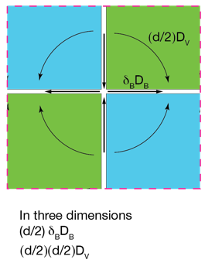

UNIT PROBLEM



Write a short narrative on what you perceive to be the difference between the idealized figure for atom transport on the left and the more realistic picture of mass transport in a large polycrystal on the right. (Keep it simple.)

04C.3

This problem explores the relationship between the diffusion coefficient for solid-state diffusion close to the melting point and the viscosity of the molten metal.

The viscosity of a liquid and the coefficient of diffusion of the atoms in the liquid is given by the Stokes Einstein equation (1)

It is to be expected that  at the melting point since there is volumetric expansion when the solid melts which will increase the diffusion relative to the solid.

From the Arrhenius plot of solid-state diffusion in copper on the right the diffusion coeffcient at the melting point is given by



.

In Eq. (1)

*kB* = 1.36*10–23 J K–1

TM(copper) = 1356 K

 Pa s

 = 0.227 nm (calculated from the molecular wt, the density and the Avogadro's Number)

You can then show that for copper at its melting point:

 (2)*

Calculate the ratio on the left hand side for ICE/WATER at 273 K assuming that  for ice is the same as for copper, that is 6*10–13 m2s–1.

The viscosity for water at the melting point is 1.8*10–3 Pa s.

Show that the ratio as in Eq. (2) is within one order of magnitude for ice and copper, even though they are two very very different substances.

*melting is a phase transformation, therefore, properties such as the viscosity undergo a step change at the transition.